Change the emblem opening gate with this emblem
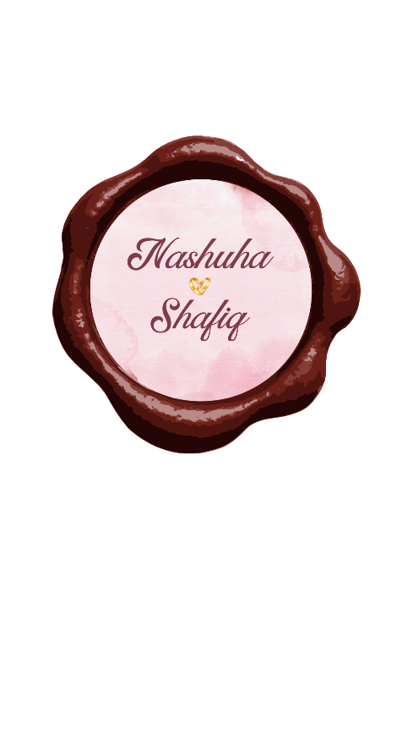
- Add note “Click to open the card”
- So when user click the emblem the transition on to next page
Change this

with style in image below, can refer to code https://github.com/Jayyawesome/Nashuha-Shafiq

Last page make it like image below


for galery use code below but make it horizontal swipe not vertical swipe
"use client"

import { useState, useCallback, useEffect, useRef } from "react"
import { motion, type PanInfo } from "framer-motion"
import Image from "next/image"

const images = [
{
id: 1,
src: "https://hebbkx1anhila5yf.public.blob.vercel-storage.com/attachments/gen-images/public/luxury-black-sneaker-with-red-sole-on-grey-backgro-hj40sZT8MUUSeLz18VN7EjhcnV0kSD.jpg",
alt: "Black sneaker with red sole",
},
{
id: 2,
src: "https://hebbkx1anhila5yf.public.blob.vercel-storage.com/attachments/gen-images/public/white-minimalist-sneaker-on-light-background-xQxkXgGrSrAe6pvLPNC6yrh20Atqoa.jpg",
alt: "White minimalist sneaker",
},
{
id: 3,
src: "https://hebbkx1anhila5yf.public.blob.vercel-storage.com/attachments/gen-images/public/navy-blue-running-shoe-on-gradient-background-E1spqSK9gDvh3gTNwASkttEg76nZgm.jpg",
alt: "Navy blue running shoe",
},
{
id: 4,
src: "https://hebbkx1anhila5yf.public.blob.vercel-storage.com/attachments/gen-images/public/red-athletic-sneaker-on-dark-background-skamDX1NbCRW4jvHxijkfmCnHGr6NJ.jpg",
alt: "Red athletic sneaker",
},
{
id: 5,
src: "https://hebbkx1anhila5yf.public.blob.vercel-storage.com/attachments/gen-images/public/green-forest-hiking-boot-on-natural-background-T41PNLzI60G2u6rFIRxeCbKT6RWKOH.jpg",
alt: "Green hiking boot",
},
]

export function VerticalImageStack() {
const [currentIndex, setCurrentIndex] = useState(0)
const lastNavigationTime = useRef(0)
const navigationCooldown = 400 // ms between navigations

const navigate = useCallback((newDirection: number) => {
const now = Date.now()
if (now - lastNavigationTime.current < navigationCooldown) return
lastNavigationTime.current = now

setCurrentIndex((prev) => {
if (newDirection > 0) {
return prev === images.length - 1 ? 0 : prev + 1
}
return prev === 0 ? images.length - 1 : prev - 1
})
}, [])

const handleDragEnd = (_: MouseEvent | TouchEvent | PointerEvent, info: PanInfo) => {
const threshold = 50
if (info.offset.y < -threshold) {
navigate(1)
} else if (info.offset.y > threshold) {
navigate(-1)
}
}

const handleWheel = useCallback(
(e: WheelEvent) => {
if (Math.abs(e.deltaY) > 30) {
if (e.deltaY > 0) {
navigate(1)
} else {
navigate(-1)
}
}
},
[navigate],
)

useEffect(() => {
window.addEventListener("wheel", handleWheel, { passive: true })
return () => window.removeEventListener("wheel", handleWheel)
}, [handleWheel])

const getCardStyle = (index: number) => {
const total = images.length
let diff = index - currentIndex
if (diff > total / 2) diff -= total
if (diff < -total / 2) diff += total

if (diff === 0) {
return { y: 0, scale: 1, opacity: 1, zIndex: 5, rotateX: 0 }
} else if (diff === -1) {
return { y: -160, scale: 0.82, opacity: 0.6, zIndex: 4, rotateX: 8 }
} else if (diff === -2) {
return { y: -280, scale: 0.7, opacity: 0.3, zIndex: 3, rotateX: 15 }
} else if (diff === 1) {
return { y: 160, scale: 0.82, opacity: 0.6, zIndex: 4, rotateX: -8 }
} else if (diff === 2) {
return { y: 280, scale: 0.7, opacity: 0.3, zIndex: 3, rotateX: -15 }
} else {
return { y: diff > 0 ? 400 : -400, scale: 0.6, opacity: 0, zIndex: 0, rotateX: diff > 0 ? -20 : 20 }
}
}

const isVisible = (index: number) => {
const total = images.length
let diff = index - currentIndex
if (diff > total / 2) diff -= total
if (diff < -total / 2) diff += total
return Math.abs(diff) <= 2
}

return (
<div className="relative flex h-screen w-full items-center justify-center overflow-hidden bg-background">
{/* Subtle ambient glow */}
<div className="pointer-events-none absolute inset-0">
<div className="absolute left-1/2 top-1/2 h-[600px] w-[600px] -translate-x-1/2 -translate-y-1/2 rounded-full bg-foreground/[0.02] blur-3xl" />
</div>

{/* Card Stack */}
<div className="relative flex h-[500px] w-[320px] items-center justify-center" style={{ perspective: "1200px" }}>
{images.map((image, index) => {
if (!isVisible(index)) return null
const style = getCardStyle(index)
const isCurrent = index === currentIndex

return (
<motion.div
key={image.id}
className="absolute cursor-grab active:cursor-grabbing"
animate={{
y: style.y,
scale: style.scale,
opacity: style.opacity,
rotateX: style.rotateX,
zIndex: style.zIndex,
}}
transition={{
type: "spring",
stiffness: 300,
damping: 30,
mass: 1,
}}
drag={isCurrent ? "y" : false}
dragConstraints={{ top: 0, bottom: 0 }}
dragElastic={0.2}
onDragEnd={handleDragEnd}
style={{
transformStyle: "preserve-3d",
zIndex: style.zIndex,
}}
>
<div
className="relative h-[420px] w-[280px] overflow-hidden rounded-3xl bg-card ring-1 ring-border/20"
style={{
boxShadow: isCurrent
? "0 25px 50px -12px hsl(var(--foreground) / 0.15), 0 0 0 1px hsl(var(--foreground) / 0.05)"
: "0 10px 30px -10px hsl(var(--foreground) / 0.1)",
}}
>
{/* Card inner glow - uses foreground with low opacity */}
<div className="absolute inset-0 rounded-3xl bg-gradient-to-b from-foreground/10 via-transparent to-transparent" />

<Image
src={image.src || "/placeholder.svg"}
alt={image.alt}
fill
className="object-cover w-full h-full"
draggable={false}
priority={isCurrent}
/>

{/* Bottom gradient overlay - uses background color */}
<div className="absolute inset-x-0 bottom-0 h-32 bg-gradient-to-t from-background/60 to-transparent" />
</div>
</motion.div>
)
})}
</div>

{/* Navigation dots */}
<div className="absolute right-8 top-1/2 flex -translate-y-1/2 flex-col gap-2">
{images.map((_, index) => (
<button
key={index}
onClick={() => {
if (index !== currentIndex) {
setCurrentIndex(index)
}
}}
className={`h-2 w-2 rounded-full transition-all duration-300 ${
index === currentIndex ? "h-6 bg-foreground" : "bg-foreground/30 hover:bg-foreground/50"
}`}
aria-label={`Go to image ${index + 1}`}
/>
))}
</div>

{/* Instruction hint */}
<motion.div
className="absolute bottom-12 left-1/2 -translate-x-1/2"
initial={{ opacity: 0, y: 20 }}
animate={{ opacity: 1, y: 0 }}
transition={{ delay: 1, duration: 0.6 }}
>
<div className="flex flex-col items-center gap-2 text-muted-foreground">
<motion.div
animate={{ y: [0, -8, 0] }}
transition={{ repeat: Number.POSITIVE_INFINITY, duration: 1.5, ease: "easeInOut" }}
>
<svg
width="24"
height="24"
viewBox="0 0 24 24"
fill="none"
stroke="currentColor"
strokeWidth="1.5"
strokeLinecap="round"
strokeLinejoin="round"
>
<path d="M12 5v14M5 12l7-7 7 7" />
</svg>
</motion.div>
<span className="text-xs font-medium tracking-widest uppercase">Scroll or drag</span>
<motion.div
animate={{ y: [0, 8, 0] }}
transition={{ repeat: Number.POSITIVE_INFINITY, duration: 1.5, ease: "easeInOut" }}
>
<svg
width="24"
height="24"
viewBox="0 0 24 24"
fill="none"
stroke="currentColor"
strokeWidth="1.5"
strokeLinecap="round"
strokeLinejoin="round"
>
<path d="M12 5v14M19 12l-7 7-7-7" />
</svg>
</motion.div>
</div>
</motion.div>

{/* Counter */}
<div className="absolute left-8 top-1/2 -translate-y-1/2">
<div className="flex flex-col items-center">
<span className="text-4xl font-light text-foreground tabular-nums">
{String(currentIndex + 1).padStart(2, "0")}
</span>
<div className="my-2 h-px w-8 bg-foreground/20" />
<span className="text-sm text-muted-foreground tabular-nums">{String(images.length).padStart(2, "0")}</span>
</div>
</div>
</div>
)
}

